You’ve got them. Why Not Use Them?

People configure their desktops in different ways for an all encompassing assortment of reasons. Most use the Windows defaults which are quite reasonable, but operate from a false assumption that “factory specifications” are enough. Windows has lots of useful features not included in the default settings which could have great benefits, but if one doesn’t know the features are there, one can never enjoy these prospective benefits.

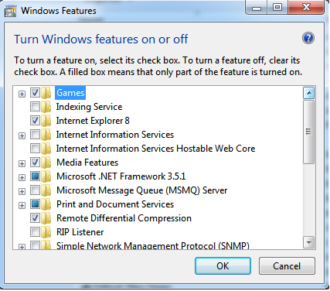
Let’s start by opening the Control Panel and clicking on Programs. In the Programs and Features section click the Turn Windows Features on or off. A dialog box appears which will enable you to turn features on or off. (See illustration).

There’s probably much more here than you want, so let’s examine several features that you are more likely to use rather than the ones which require professional technical knowledge to be useful.

The Indexing Service got a bad reputation in Vista because it was annoyingly slow. There is no doubt that Vista was a resource hog so any service or utility that had additional requirements tended to bog down the system even further. Microsoft resolved the problem in Windows 7 by turning the Indexing Service off by default. That’s too bad because the utility can actually be very helpful in locating files and other content through flexible inquiries. Try it, you just may like it.

Internet Information Services (IIS) and Internet Information Services Hostable Web Core: You will not be held accountable if you don’t know what these tools do or if you choose to ignore them. IIS is mostly regarded as a major component of a server while the Hostable Web Core performs fewer functions and needs fewer resources. If you write web based applications or wish to experiment hosting a web site on your desktop, these tools may be essential.

Microsoft Message Queue Server: This utility has been around for years and most application developers have come to ignore it because it’s not new. If you send and receive messages on a regular basis with people who are in remote locations on the planet, and have “iffy” connections, you now have a tool to build a message queue, store a message within it, and send it when the connection to the recipient is up and running. You can also create a similar structure for receiving messages. Using this tool effectively requires basic programming skills.

Simple Network Management Protocol (SNMP): Everyone who uses a computer on a regular basis should be concerned about unauthorized access to personal information or attempts to trick people into revealing information which should remain private. If you have a home network, wireless or not, SNMP gives you better control over devices on the network. You can configure hardware, troubleshoot more effectively, and in many cases even track down attempts to crack into your network. This tool requires a working knowledge of how a network operates.

Telnet Client: This is a great diagnostic tool if your email client is acting strangely and normal diagnostics can not resolve the problem. Turn it on when you need it, and turn it off when you’re not using it as there are security issues with it.

These tools are not for everyone, especially those with little computing experience, but your level of knowledge shouldn’t remain at the novice stage. Challenge yourself and you won’t be like the guy who thinks he has twenty years of experience when in reality all he has is one year of experience twenty times. :

